Dear All,

For the EinStein würfelt nicht! game, my student Hsieh, Chang-Long has already developed an environment that two programs can play the game automatically without manual operation. This will reduce the tournament time and the luck factor if we can play 50 or more games with each other. For example, using the sample EWN program test.exe as both side, it takes about 75 minutes to play 50 games automatically.

You can run ECUI.exe and then press Start to test it quickly. Hopefully we can use this in TCGA 2016 and ICGA 2016.

If you want to use this protocol in the tournament, you can look at the following Instructions for running the ECUI.exe program. Please tell me if you encounter any problems. Thanks.

Best wishes,

Shun-Shii Lin

Professor,

Department of Computer Science and Information Engineering

National Taiwan Normal University

<linss@csie.ntnu.edu.tw>

======================================================

Instructions for running the ECUI.exe program

ECUI.exe: a program for EinStein würfelt nicht! game. It can be used to run two EWN programs, an EWN program versus a human player, or two human players.

test.exe: a sample simple EWN program that can be used to test ECUI.exe.

test.cpp: the source code of the sample EWN program that can be modified for writing your own EinStein würfelt nicht! program in order to use ECUI.exe platform. More detailed information about the coding can be found in "EinStein würfelt nicht! AI instructions.txt"

1. Interface: Please Run ECUI.exe in the ECUI folder.

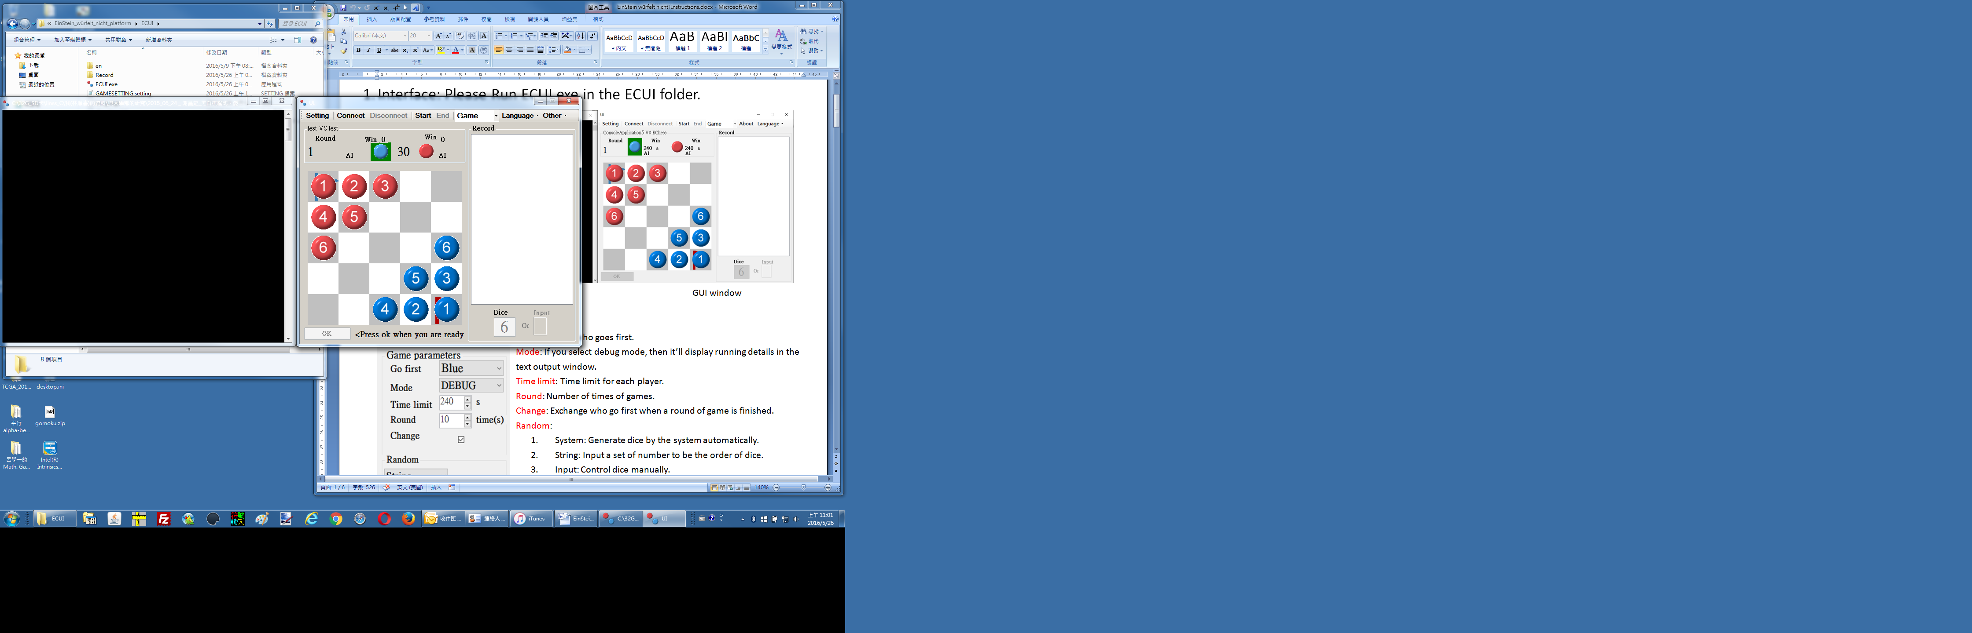

text output window GUI window

1. Settings: Press "Setting".

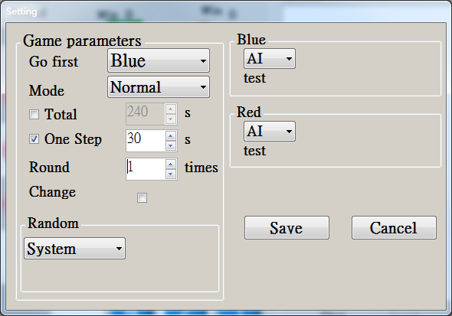

Go first: Select who (either Blue or Red) goes first.

Mode: If you select Debug mode, then it’ll display running details in the text output window.

Total: Total thinking time for each player. For example, 240 seconds for each player.

One Step: Thinking time per move. For example, 30 seconds per move.

Round: Total number of games.

Change: Check this box if you want to automatically exchange who goes first when a game is finished.

Random: We have four kinds of dice outcomes to choose from:

1. System: automatically generate the dice outcomes by the system using random number generator.
2. String: input a set of numbers manually to be the order of dice outcomes for a sequence of moves.
3. Input: input the dice outcome manually one by one for each move.
4. Seed: input a number to be the seed of the random number generator, and the system will generate the dice outcome automatically.

Blue/Red: Select People or AI to be the Blue/Red player.

People: Blue/Red side is played by human.

AI: Blue/Red side is played by an AI program that can be assigned by dragging the AI execution file (for example, test.exe) into the following box.

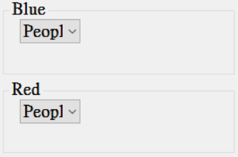

Save: Save the current configuration and it will be used in the later games.

1. Start Game

Press “Start” to start the game, and press “End” to finish the game.

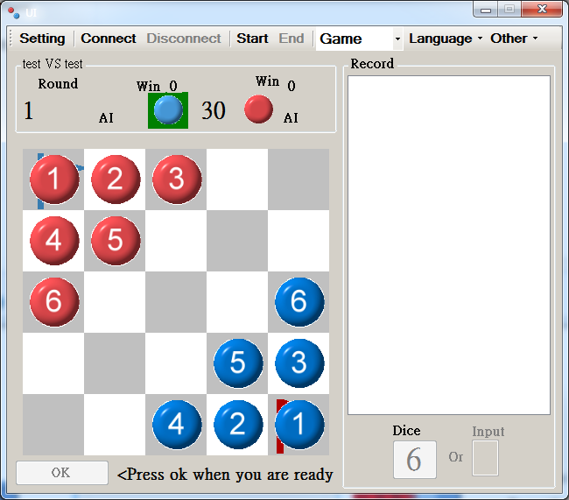

If there is human player, he/she can set the initial positions of his/her pieces before starting a round of game.

Just click a piece and then click another piece, and their positions will be exchanged.

If all settings are ready, Press “OK” button to start the game.

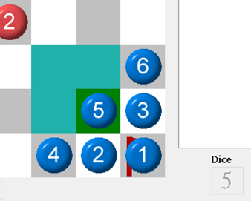During the game, the green area shows the piece you can move.

The Indigo area shows the positions where you can move to now.

Click the target position to move your piece.

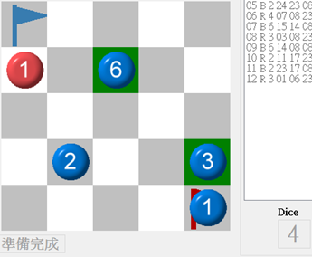If the dice number doesn't match any of your pieces, the system will mark the pieces that you can move now. Click one of them to choose the piece you want to move and then click the target position to move this piece.

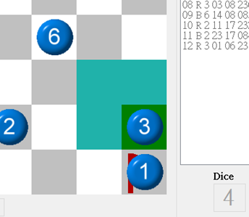

1. Record

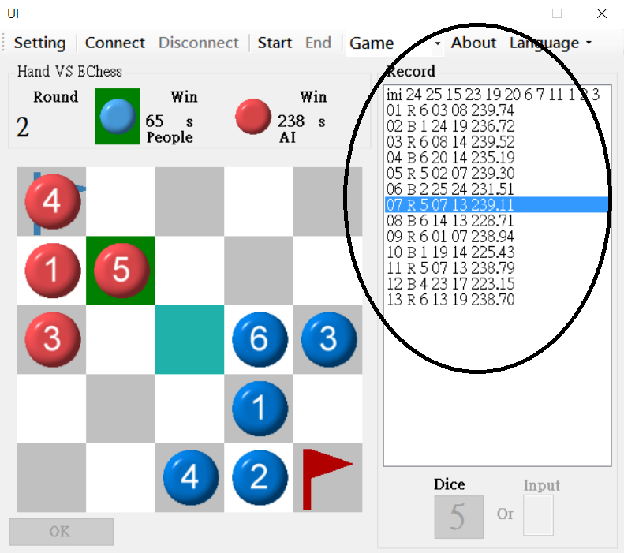

The circled part shows the record of a game. Choose one of its line to display the record of the game.

1. Connect

Press “Connect” button to connect to a remote game server. This is only used for an AI program versus another AI program where the players can’t generate dice manually. Press button “Disconnect” to disconnect.

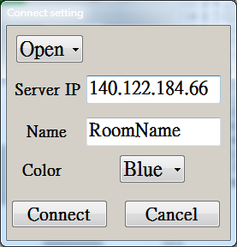Select mode:

Open: Create a new room, and you can set the parameters of the game.

Enter: Enter a room which has already been created.

Room name: Identify a name of the room.

Color: the color of the player who creates the room.

1. Mode switching

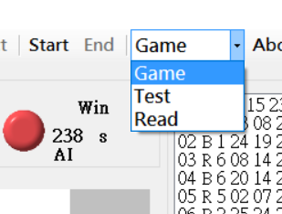

Game: Gaming.

Test: Test for AI.

Read: Read and display the record of games.

1. Testing mode

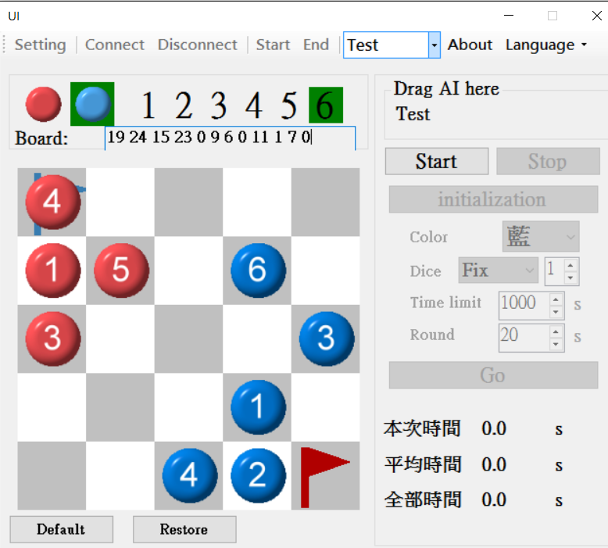

The area whose background is green denotes the piece you select.

Click left mouse button to put the piece you select on the chess board.

Click mouse wheel (middle button) on piece to remove it.

Roll mouse wheel to switch pieces (or click left mouse button on the dark green area to select)

Click right mouse button to exchange color.

1. Reading mode

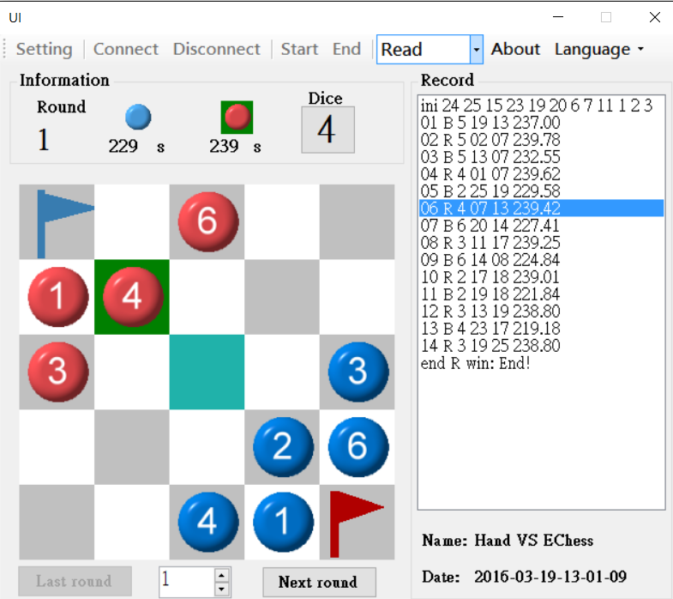This feature can read game record played before.

Game record is stored in the folder “Record”.

The system will create the folder when the folder doesn’t exist.

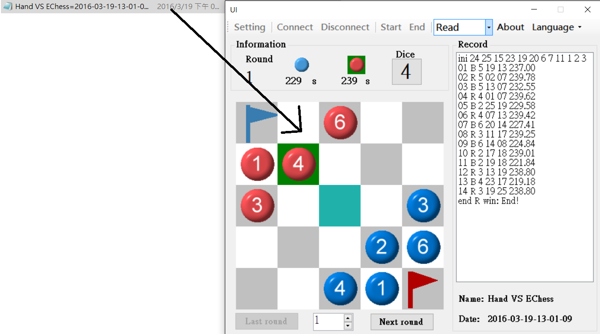

Drag record file to any area of the interface and open the record file immediately.

Click the lines in the area of record at the right side of interface to display the record. (or use mouse wheel to display.)

1. Languages

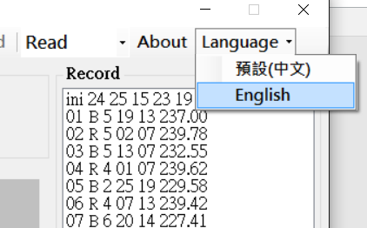

You can select languages here.

There are only two selections at the present time, Traditional Chinese and English.